NEXTAG COMPANY

GG Black men's bag

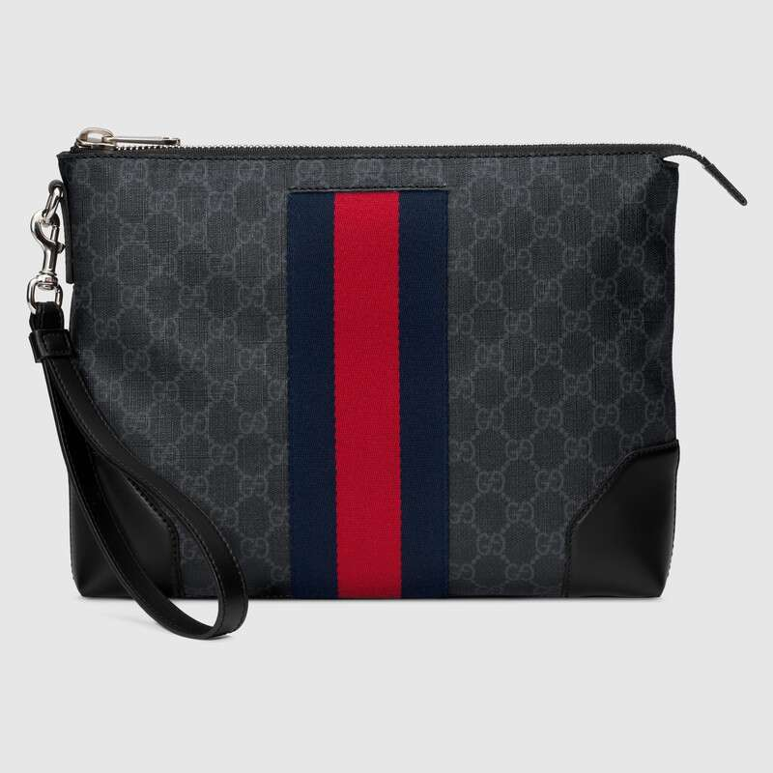

Style # 523603 9F2YN 1095

Product Description

First used in the 1970s, the GG logo was an evolution of the original Gucci rhombi design from the 1930s, and from then it's been an established symbol of Gucci's heritage. This men's bag combines the signature motif with the Web stripe—a timeless pairing that pays homage to Gucci's roots.

Blue and red Web • Palladium-toned hardware • GG Black • Interior zipper

pocket and two smartphone pockets • Detachable

wrist strap with 7" drop • Zipper closure • Made in Italy

PRODUCT DETAILS

Style ‎523603 9F2YN 1095

First used in the 1970s, the GG logo was an evolution of the original Gucci rhombi design from the 1930s, and from then it's been an established symbol of Gucci's heritage. This men's bag combines the signature motif with the Web stripe—a timeless pairing that pays homage to Gucci's roots.

* Black/grey GG Supreme canvas, a material with low environmental impact
* Blue and red Web
* Palladium-toned hardware
* Interior zipper pocket and two smartphone pockets
* Detachable wrist strap with 7" drop
* Zipper closure
* W12" x H9.5" x D2"
* Cotton linen lining
* Made in Italy